Decoration Ideas

The FUNdamentals theme is all about brick walls, from colorful graffiti to Nehemiah’s wall brought to life through the Bible stories and Response Times.

Setting the stage: Start by thinking about the backdrop for your Rally Area stage. Here are some ideas:
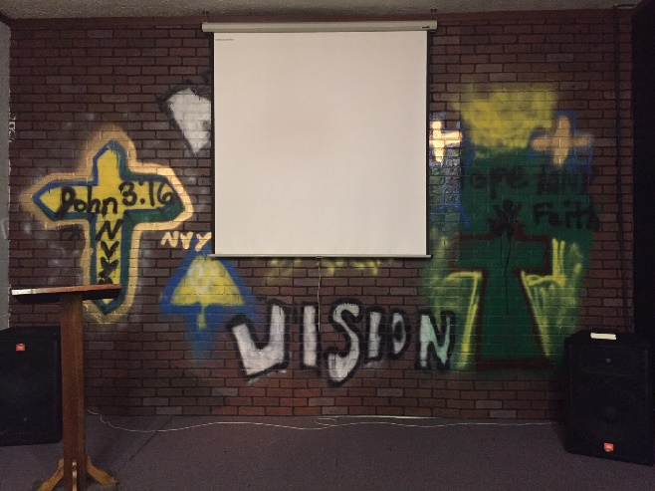
Purchase “brick” paneling from your local lumber center. Paint it with faith-inspired graffiti in bright colors. This is a great way to get your youth group involved! Then lean it against the back wall or build a simple frame to hold it up.
Don’t want to paint? Add the MEGA Point and MEGA Verse posters from the Fundamentals Kit to give it some color.

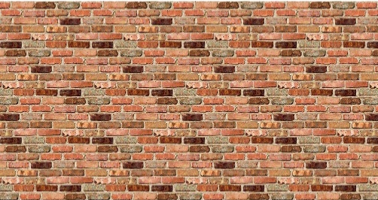
Can’t get paneling in a brick pattern? Another option is to order a roll of brick paper like this one. Both links below feature paper that is 4 ft. x 50 ft long, which gives you plenty of brick paper to decorate the stage. Add the Posters or print extra art from the Flash Drive for graffiti that matches the theme.

https://www.amazon.com/Fadeless-PAC57465-Bulletin-Board-Reclaimed/dp/B01BIPGZ4U/ref=sr_1_3?ie=UTF8&qid=1544384195&sr=8-3&keywords=brick+paper+roll+for+bulletin+board

https://www.orientaltrading.com/fadeless-brick-paper-roll-a2-13702908.fltr?keyword=brick+paper&originalkeyword=brick+wallpaper

Decorate the Rooms

Add a brick wall to the rooms and hallways too. Just cut the paper roll into strips and use painter’s tape to affix it to the wall. Adding a foot or two to the wall each day is a fun way to show how Jerusalem’s wall got higher as the Israelites continued to build. Personalize the walls by letting kids write their name on it using colored chalk.

Make Your Own Wall
with Response Pages

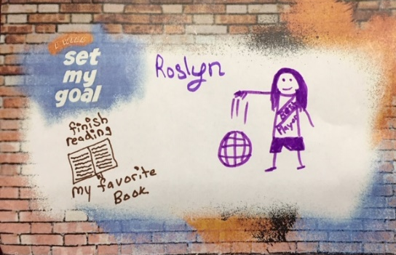
The FUNdamentals Sports Flash has ready-to-use Response Pages that are designed to make a brick wall too. Days 1 through 4 end with the kids applying the day’s MEGA Point to their life. A simple way to add a wall is to tip a table on its side and add Response Page bricks each day.

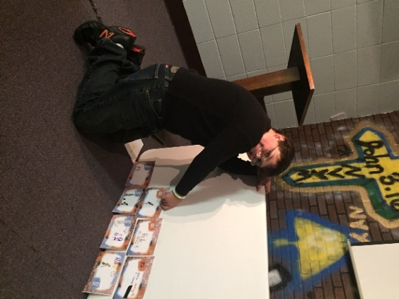

If you have a smaller group, you might want to let the kids add their own bricks to build the wall.

For large groups, you’ll want to collect the pages and add to the wall after the kids go home. You may even want to add the bricks on top of the brick paper you’ve added around the rooms. Kids will have fun finding their bricks the next day.

Share your great decorating ideas
#MEGASportsCamp

